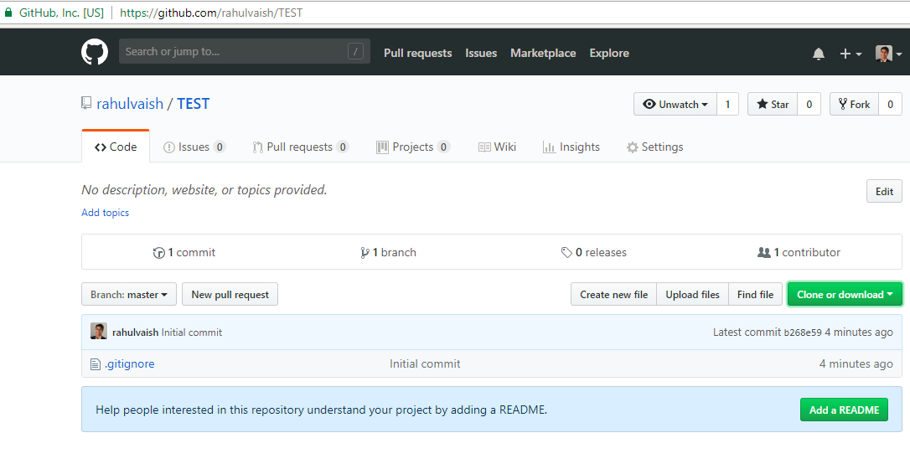

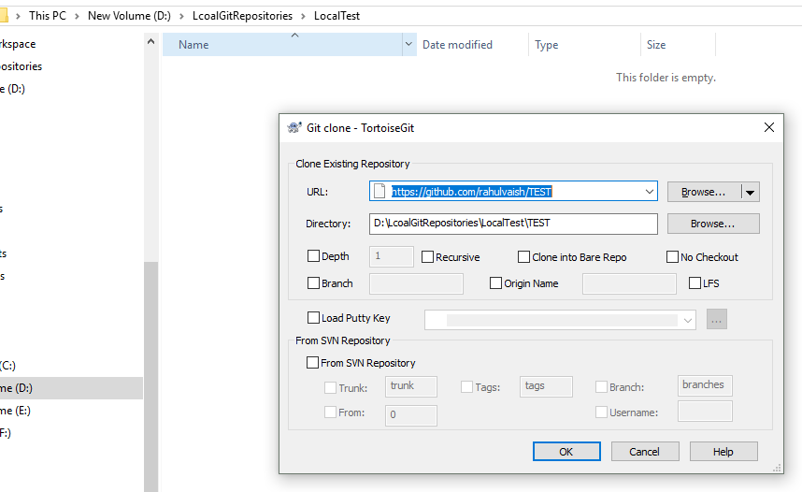

Or

**git clone “https://github.com/rahulvaish/TEST”**

Now launch eclipse and making its workspace as LocalTest/Test:

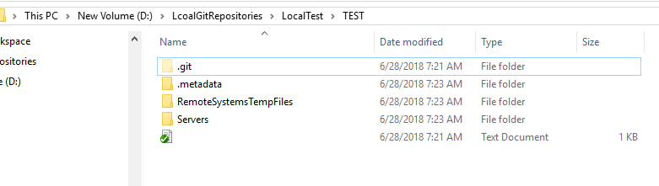

Now create a fresh project here

